MECH 420 – Lab Report #1

Kyle Ah Von #57862609

#### Prepare one graph for each proximity sensor showing the sensor signal for all test targets as a function of distance between the sensor and the test targets. Use the distance measured by the dial gauge as the reference distance.

**

Figure 1: IR Sensors Results

The IR Sensor has a much better output voltage scale for the Shiny Aluminum sample as compared to other material sample.

Notice how the acrylic sample also has an unexpected local minimum before it resumes the expected response for both the forward and backward motions.

**Capacitive Switch results:**

Figure 2: Capacitive Sensor Results

The switch value for the capacitive switch is around 5 mm for the forward motion and the switch point is about to be slightly larger than the initial switch value.

The switch value is much smaller for the acrylic sample compared to the metallic material sample.

**Eddy Current Sensor Results:**

Figure 3: Eddy Current Sensor Results

The acrylic sample seems to not be detectable by the Inductive sensor, which makes sense since acrylic cannot conduct electricity.

**LED Sensor Results:**

Figure 4: LED Sensor Results

The Acrylic sample seems to cause some irregular behaviour in the LED sensor results. The difference in the space between both upward linear graphs can be due to the transparency of the material and the thickness of the acrylic sample. The LED sensor picks up the first surface and then picks up the second boundary on the other side of the sample.

##### Compare your observations for all 4 sensors to the specifications in the data sheets and in this lab manual. Comment on range, linearity and hysteresis for each sensor.

**IR Sensor Results:**

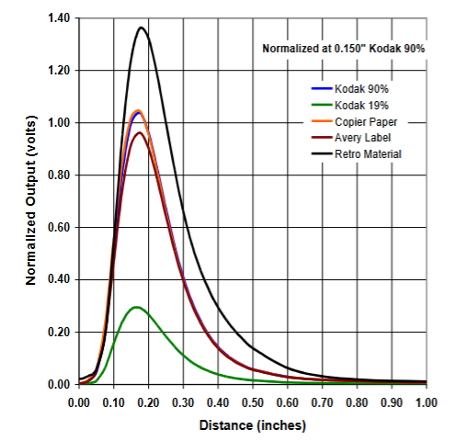

Range: Based on the experimental data, the range appears to be approximately 0-20 mm. This aligns well with first image, which shows a range of 0-1 inch (0-25.4 mm).

Linearity: The IR sensor response is highly non-linear. As seen in the first image, the response curves for different materials all show a peaked, non-linear shape. The experimental data also shows this non-linear behavior.

Hysteresis: The data shows some hysteresis, as evidenced by the differences between forward and backward measurements. This is particularly noticeable for the shiny aluminum sample.

**Capacitive Sensor Results:**

Range: The data suggests a very short range, with a clear switching point around 4-5 mm for most materials.

Linearity: The capacitive sensor appears to have a binary (on/off) response rather than a linear one. It switches rapidly from high to low voltage at a specific distance.

Hysteresis: There's significant hysteresis evident in the data, with different switching points for forward and backward motion. This is particularly clear in the plots for shiny aluminum and steel.

This hysteresis is a feature of switches. It provides a small buffer range in case the material is stuck at this distance which prevents the signal to fluctuates from low to high and vice versa.

**Eddy Current Sensor Results:**

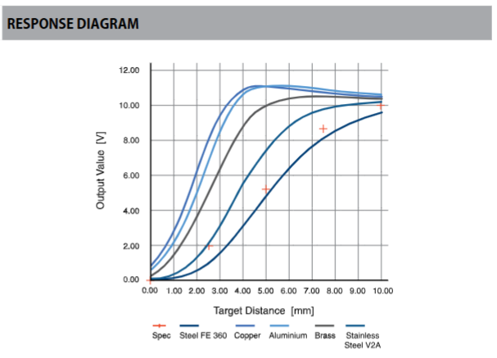

Range: The experimental data shows a range of about 0-9 mm. This is consistent with the first image, which shows responses up to 10 mm.

Linearity: The eddy current sensor shows a more linear response compared to the IR sensor, especially in the middle of its range. However, it still has some non-linearity, particularly at very close distances and at the far end of its range.

Hysteresis: The data shows minimal hysteresis for the eddy current sensor, with forward and backward measurements closely overlapping.

**LED Sensor Results:**

Range: The data indicates a range of about 15-26 mm, which is broader than the other sensors.

Linearity: The LED sensor response appears to be somewhat linear over part of its range, but with non-linear behavior at the extremes.

Hysteresis: There's some visible hysteresis in your data, particularly for the shiny aluminum and steel samples.

Here is a compiled table for Hysteresis Errors (%)

|  |  |  |  |  |
| --- | --- | --- | --- | --- |
|  | Shiny Aluminum | Sand Blasted Aluminum | Steel | Acrylic |
| IR Sensor | 3.81 | 3.61 | 3.88 | 2.12 |
| Capacitive Sensor | N/A | N/A | N/A | N/A |
| Eddy Current Sensor | 2.94 | 4.22 | 1.57 | N/A |
| LED Sensor | 1.25 | 0.93 | 1.06 | N/A |

#### Determine the calibration equation for both the LED position sensor and the IR reflective object detector for the shiny aluminum test target. For the IR sensor, only fit to the data in the non-linear region at distances greater than the signal peak, for example starting around 5 mm. a) Provide the calibration equations for both sensors. b) Provide one plot for each sensor showing the measured data and the fit curve.

Calibration Equations:

LED Sensor:

LED Sensor:

##### What type of proximity sensor would you use for the following tasks? Explain.

##### Detecting whether a conductive object is present.

For detecting the presence of a conductive object, the Eddy Current Sensor would be the most suitable choice. As observed in the experimental results, the Eddy Current Sensor showed a clear response to metallic samples (shiny aluminum, sand-blasted aluminum, and steel) while showing no response to the non-conductive acrylic sample. The report states, "The acrylic sample seems to not be detectable by the Inductive sensor, which makes sense since acrylic cannot conduct electricity." This specificity to conductive materials makes the Eddy Current Sensor ideal for this task.

The sensor's short range (approximately 0-9 mm based on the experimental data) is well-suited for proximity detection. While the sensor provides distance information, it can be easily configured to give a binary output indicating the presence or absence of a conductive object within its detection range.

##### Determining the approximate distance of an opaque object.

For determining the approximate distance of an opaque object, the LED Sensor would be the most appropriate choice. The experimental results show that the LED Sensor has several advantages for this application. The data indicates a range of about 15-26 mm, which is broader than the other sensors tested, allowing for more flexibility in distance measurement. The report notes, "The LED sensor response appears to be somewhat linear over part of its range, but with non-linear behavior at the extremes," which is beneficial for accurate distance measurements within the sensor's optimal range. Additionally, the compiled table of Hysteresis Errors shows that the LED Sensor has the lowest hysteresis among the sensors tested, with errors of 1.25%, 0.93%, and 1.06% for shiny aluminum, sand-blasted aluminum, and steel respectively.

The LED Sensor offers further advantages for this task. A calibration equation is provided (𝑆 = −15.07 + 𝑥), which can be used to convert the sensor output to actual distance measurements. Unlike the Eddy Current Sensor, the LED Sensor can detect both conductive and non-conductive materials, making it suitable for a wider range of opaque objects. While the IR Sensor could also be considered for distance measurement, its highly non-linear response and higher hysteresis make it less suitable than the LED Sensor for this task. The LED Sensor's combination of range, linearity, low hysteresis, calibration capability, and versatility make it the optimal choice for determining the approximate distance of an opaque object.